Contents

1. INTRODUCTION 2

1.1 App Purpose 3

1.2 App Scope 3

1.3 Goals of the Team 3

1.4 Process Model 3

1.5 Team Organization 4

2. RESEARCH 4

2.1 Market Research: 4

2.1.1 Industry Trends 4

2.1.2 Competitive Analysis 4

2.1.3 Target Audience 5

2.2 Technical Research: 5

2.2.1 Technology Stack 5

3. DESCRIPTION 6

3.1 Home Page: 6

3.2 Dashboard: 6

3.3 Registration: 7

3.4 Login: 7

3.5 Logout: 7

3.6 User Management: 7

4. Requirements 7

4.1 Hardware Requirements 7

4.4.1 For Development 7

4.4.2 For Hosting 8

4.2 Performance requirement 8

4.2.1 Page Load Speed 8

4.2.2 Responsiveness 8

4.2.3 Scalability 8

4.2.4 Server and Backend Performance 9

4.3 Software Requirements 9

4.3.1 Development Environment 9

4.3.2 Frontend Requirements 9

4.3.3 Backend Requirements 9

4.3.4 Additional Tools 9

4.3.5. Third-Party Services 10

5. SYSTEM ANALYSIS AND MODELING 10

5.1 Functional Modeling 10

5.1.1 Level 0 of Data Flow Diagram 10

5.1.2 Level 1 of Data Flow Diagram 11

# 1. INTRODUCTION

The Online Bookstore is a modern web application designed to deliver a simple, intuitive, and user-friendly platform for accessing a diverse collection of digital books. Focused on open access, the website allows users to read books online, download them in PDF format, and rate them, all without the need for user registration or login. This approach ensures a seamless and hassle-free reading experience for all users.

Built using **React** for the frontend and **Express** for the backend, the application leverages a scalable and efficient architecture to handle content delivery, user interaction, and administrative tasks. While general users can freely interact with the book collection, an **admin panel** provides secure access for administrators to manage book entries—allowing them to **add, update, or delete** content as needed.

## 1.1 App Purpose

This section introduces the core purpose of the website — to offer a digital platform where users can freely read, download PDF versions of books, and rate them without any purchase or login requirement. The site will be managed solely by the admin.

## 1.2 App Scope

The app will include the following key features:

1. Public users can browse, search, read, download, and rate books.
2. No user authentication or accounts.
3. Admin functionalities include adding, updating, or deleting books and monitoring ratings.
4. The system does not include payment, cart, or purchase systems.

## 1.3 Goals of the Team

The primary goals of the development team are:

1. Developing a clean and accessible interface.
2. Ensuring fast book retrieval and download.
3. Implementing secure and efficient admin controls.
4. Providing a scalable and maintainable backend.

## 1.4 Process Model

The development process follows an **Agile methodology** with the following stages:

1. **Requirement Gathering**: Identifying user needs, app functionalities, and technical specifications.
2. **Design & Prototyping**: Creating wireframes, mockups, and prototypes for both the frontend and backend.
3. **Development & Implementation**: Dividing tasks into sprints, building components and APIs iteratively using **React** and **Express**.
4. **Testing & Debugging**: Conducting unit, integration, and user acceptance testing (UAT) to ensure quality and stability.
5. **Deployment**: Preparing the app for deployment on cloud platforms (e.g., Vercel, Heroku) and making it publicly accessible.
6. **Maintenance & Updates**: Continuously improving the app based on user feedback and monitoring its performance.

## 1.5 Team Organization

The development team is organized into specialized roles:

1. **Frontend Developer(s)**: Focus on implementing the user interface using **React**, integrating with the backend, and ensuring the UI is responsive and visually appealing.
2. **Backend Developer(s)**: Work on setting up and maintaining the **Express** backend, developing APIs for data management, admin authentication, and integrating with the frontend.
3. **Quality Assurance (QA) Engineer**: Responsible for testing the app across different devices and ensuring all features work as expected.
4. **Project Manager**: Oversees the entire development process, manages timelines, ensures the team follows the Agile process, and communicates with stakeholders.

# 2. RESEARCH

## **2.1 Market Research:**

### **2.1.1 Industry Trends**

1. The **digital publishing industry** has undergone significant transformation in recent years, with online book platforms becoming a central hub for educational access, leisure reading, and literary engagement.
2. As of 2024, **millions of digital books** are available worldwide, spanning academic, fiction, non-fiction, and self-published works. The growth of open-access resources and free eBook repositories has made literature more accessible than ever.
3. There is a **rising demand for free, user-friendly platforms** where readers can access content without paywalls or login barriers. Simplicity and instant access are key drivers of user engagement.
4. **Mobile device usage** dominates digital reading trends, with more than **60% of users** accessing book content through smartphones or tablets. Responsive design and mobile optimization are therefore essential.

### **2.1.2 Competitive Analysis**

1. **Competitors**: Leading platforms such as **Project Gutenberg**, **Open Library**, and **PDF Drive** dominate the free eBook market. These sites offer vast collections, easy access, and simple navigation, making them popular among readers worldwide. However, many of them lack interactive features like integrated rating systems or modern, responsive interfaces.
2. **Opportunities**: By providing a **cleaner, more modern user interface**, **PDF downloads without login**, and a **book rating system**, our platform can stand out from traditional competitors. Additionally, implementing features such as **smart search**, **top-rated book sections**, and **mobile-optimized reading views** presents an opportunity to attract users looking for both ease of use and a richer user experience.

### **2.1.3 Target Audience**

1. **Primary Audience:**
   * **Students, researchers, and general readers** who seek a free, easy-to-use platform to **access, read, and download books** without registration.
   * Individuals interested in **academic, fiction, or non-fiction content**, who value convenience, simplicity, and quick access to digital books.
   * Readers who prefer platforms that allow them to **rate books**, helping others find high-quality or trending content.
2. **Secondary Audience:**
   * **Educational institutions, libraries, and community learning centers** looking to recommend open-access digital platforms for learning and reference.
   * **Authors and publishers** interested in understanding reader feedback through ratings and gaining exposure on non-commercial, content-sharing platforms.

## **2.2 Technical Research:**

### **2.2.1 Technology Stack**

**Frontend:**

1. **Language:** JavaScript
2. **Framework:** React.js
   * Popular for its component-based architecture, reusable UI components, and a vast ecosystem of libraries.
   * React’s virtual DOM ensures faster updates and a responsive user experience.
   * Strong community support and compatibility with mobile development through React Native.

**Backend:**

1. **Language:** JavaScript
2. **Framework:** Express
   * Express provides a robust, high-level framework suitable for rapid development and clean, pragmatic design.
   * Features such as built-in authentication, database management, and RESTful API support streamline backend development.
   * Scalability and security are major advantages.

**Database:**

1. **Choice:** MongoDB
   * An open-source, non-relational database system that offers advanced features like JSON support, indexing, and scalability.
   * Compatible with Express’s ORM (Object Relational Mapping).

**Additional Tools:**

1. **State Management:** Redux (for managing global state in the app).
2. **Styling:** Tailwind CSS.
3. **APIs:** Express REST Framework (ERF) for exposing backend functionality to the frontend.
4. **Hosting:**
   * Frontend: Vercel or Netlify (optimized for React.js deployments).
   * Backend: Vercel.

# 3. DESCRIPTION

## 3.1 Home Page:

The Home Page serves as the primary interface for users, providing access to all essential features of the blogging web app. It includes:

1. Featured books carousel
2. Search bar
3. Category filters
4. Top-rated books
5. Navigation to admin panel (hidden from general users)

## 3.2 Dashboard:

The Dashboard is a personalized space for admin, providing tools to manage their content and activities. Key functionalities include:

1. **User Side (public-facing):** Book previews, download buttons, and rating inputs.
2. **Admin Side:** A secure interface to manage book content — add, edit, delete books, view download counts and ratings.

## 3.3 Registration:

Since users do **not register**, clarify that the system is fully open-access. Optionally mention that only the **admin has credentials**, and these are securely stored and managed for accessing the backend.

## 3.4 Login:

The login feature is implemented **only for the admin**, as general users are not required to register or log in to access the website. This aligns with the website's goal of providing free and open access to digital books without user accounts.

## 3.5 Logout:

Since only the admin logs in, describe a simple logout mechanism for session termination on the admin panel. May include a timeout feature for inactivity.

## 3.6 User Management:

The online bookstore is designed to provide **open and unrestricted access** to all users. There is **no requirement for user registration or login**, making the platform more accessible, faster to use, and easier to maintain. This approach encourages more users to engage with the content without barriers.

# 4. Requirements

## 4.1 Hardware Requirements

### 4.4.1 For Development

1. **Processor:** Quad-core or higher (e.g., Intel i5/i7 or AMD Ryzen 5/7).
2. **RAM:** Minimum 8GB (16GB recommended for smooth multitasking with IDEs, local servers, etc.).
3. **Storage:** SSD with at least 256GB space for projects and tools.
4. **Operating System:** Windows, macOS, or Linux.

### 4.4.2 For Hosting

1. **Small to Medium Blog**
   * **CPU:** Single-core 2GHz or better.
   * **RAM:** 1GB (2GB recommended).
   * **Storage:** 10GB SSD (expand based on content size).
2. **High Traffic Blog**
   * **CPU:** Multi-core (4 vCPUs or more).
   * **RAM:** 8GB or higher.
   * **Storage:** SSD with 100GB or more.
   * **Example:** AWS EC2 t3. medium or a similar VPS with scalable options.

## 4.2 Performance requirement

### 4.2.1 Page Load Speed

1. Time to First Byte (TTFB): Should be under 200ms.
2. Full Page Load: Aim for under 3 seconds on a 4G connection.
3. Core Web Vitals:
   * Largest Contentful Paint (LCP): < 2.5 seconds.
   * First Input Delay (FID): < 100ms.
   * Cumulative Layout Shift (CLS): < 0.1.

### 4.2.2 Responsiveness

1. **Device Compatibility:** Optimize for mobile, tablet, and desktop views.
2. **Media Optimization:** Use responsive images, lazy loading, and modern formats like
3. webp

### 4.2.3 Scalability

1. Handle increased traffic without significant performance degradation.
2. **Concurrent Users:** Define expected active users (e.g., 1000 concurrent users for a mid-tier blog).
3. **Requests per Second (RPS):** Measure API endpoints' capacity (e.g., at least 50 RPS per API).

### 4.2.4 Server and Backend Performance

1. Database Query Response: Queries should respond within 100ms.
2. Use caching mechanisms like Redis or in-memory caching for frequently accessed content.
3. Optimize backend APIs for minimal latency.

## 4.3 Software Requirements

### 4.3.1 Development Environment

1. **Programming Language:** JavaScript,
2. **Frameworks:** React
3. **Database:**
4. **Relational:** MongoDB.
5. **Web Server:**
6. Nginx or Apache for serving static content and managing requests.
7. Node.js if using server-side rendering (e.g., Next.js).
8. **Operating System:** Linux (Ubuntu, CentOS, etc.) for the server environment.

### 4.3.2 Frontend Requirements

1. HTML, CSS, JavaScript: Basic tools for building responsive and interactive UIs.
2. **CSS Frameworks:** tailwind
3. **Bundlers:** Webpack, Vite, or similar for efficient frontend build processes.

### 4.3.3 Backend Requirements

1. **API Frameworks:** REST Framework, Flask, etc.
2. **Authentication & Authorization:** Use libraries like Passport.js, Firebase Auth, or Auth0.
3. **Caching Systems:** Redis or Memcached for improving response times.

### 4.3.4 Additional Tools

1. **Version Control:** Git and platforms like GitHub or GitLab.
2. **Deployment Tools**: Docker, Kubernetes, or simple CI/CD pipelines via GitHub Actions or Jenkins.
3. **Monitoring Tools:** Prometheus, Grafana, or New Relic for server and app performance monitoring.

### 4.3.5. Third-Party Services

1. **Content Delivery Network (CDN):** Cloudflare, AWS CloudFront.
2. **Analytics Tools:** Google Analytics, Hotjar
3. **Email Service Providers:** Nodemailer, Emailjs

# 5. SYSTEM ANALYSIS AND MODELING

## 5.1 Functional Modeling

### 5.1.1 Level 0 of Data Flow Diagram

Level 0 of data flow diagram shows the interactions between the user and the website.

**High-level overview:**

1. Users interact with the system to **search**, **view**, **read**, **download**, and **rate** books.
2. Admin interacts to **manage book data**.

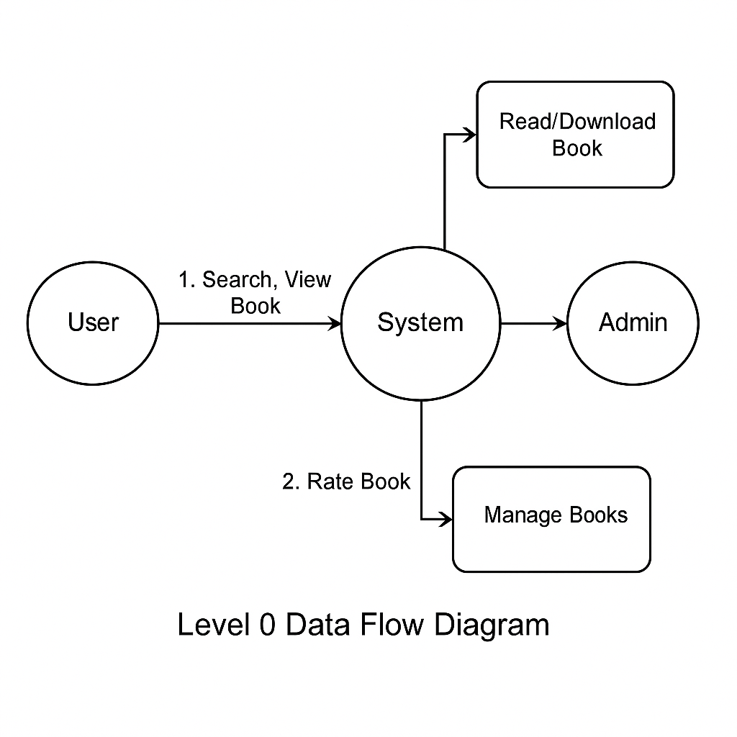

### 5.1.2 Level 1 of Data Flow Diagram

Level 1 of data flow diagram shows the details of the Blogging Website, describing the relations and interaction.

